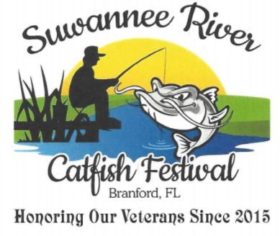

DONOR FORM
Company Name:
Address:
Contact Person:
Phone Number: E-mail:
PLEASE LIST ALL ITEMS TO BE DONATED
DONATION AMOUNT WILL BE AT FAIR MARKET VALUE

DONATION AMOUNT
Donor merchandise will be raffled off and proceeds go towards the two Scholarships for the winners of the Suwannee River essay contest, awards for the 5k run, the Catfish pageant, and donations to local charities.

CATFISH FESTIVAL REPRESENTATIVE

