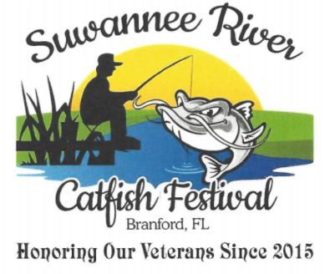

5K RUN ENTRY FORM
SATURDAY APRIL 14, 2018
Last Name:
First Name:
Address:
City: State: Zip:
Phone Number: E-mail:
Age (on race day): Date of Birth:
Sex: Male Female
T-Shirt Size: S M L XL 2XL Other
Entry Fee : Pre-registration $25.00, Race Day $35.00
In consideration of the acceptance of my entry, I do hereby release and discharge any and all claims against Suwannee River Catfish Festival, the Town of Branford, sponsors, or donors of the Suwannee River Catfish Festival, together with all their Officers, Board Members, and volunteers for any and all claims of liability. I understand there are certain dangers associated with any such athletic event and I certify that I am physically and medically able to compete in this event.
Signature of applicant or Parent/Guardian if under 1 8
Date:
Mail applications and make checks payable to:
Suwannee River Catfish Festival
P.O. Box 1 31 0
Branford, FL. 32008

