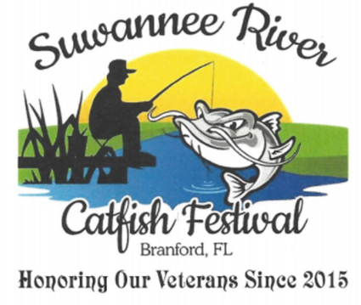

MISS CATFISH FESTIVAL
SCHOLARSHIP PAGEANT
OFFICIAL CONTESTANT ENTRY FORM
CONTESTANTS MUST LIVE WITHIN THE
SUWANNEE RIVER VALLEY AREA
Contestant
#

___________
BRANFORD HIGH SCHOOL AUDITORIUM
Saturday, February 9, 2019 at 6:00 PM
Toddler Miss & Little Miss Divisions $15.00 Contestant Fee
Pre-Teen Miss – Miss Divisions $25.00 Contestant Fee
If you have more than 1 child in the Pageant, ask about reduced fee
Make checks payable to Suwannee River Catfish Festival
Applications MUST BE received or postmarked by Saturday, Monday, Jan. 21, 2019

The following information will be announced as your child is competing on stage:
Contestant Age: ________ Name: ____________________________________________
(Age as of Pageant Date)

School Grade: _______ School Name: __________________________________________

Parents Name: _______________________________________________________________

Favorite Color: ________________ Favorite Food: ________________________________
The information below is for Suwannee River Catfish Festival Pageant Records ONLY & WILL NOT be shared with anyone or any organization.

Name: _____________________________________________________________________

Address: ______________________________________________________________

Telephone: Home _______________________ Cell ___________________________

Email Address: _________________________________________________________

Do you wish to be contacted for future pageants & events? Yes _____ No _____

X_______________________________________
Signature of Parent Guardian affirming you approve of your child’s participation.
Date App. Received ________________Paid Check ___________ Cash ____________
Suwannee River Catfish Festival will not be held responsible for any lost or stolen items or any injuries of accidents that may occur during the pageant or rehearsals.

